Software Requirements Specification (SRS)
COURSE CODE: CSE 4204 | | COURSE TITLE: MOBILE COMPUTING LAB
Semester: Fall 2026
Project Title: NUBTK_COPILOT - AI-Powered University ERP and Career Architect
Instructor: Md. Riaz Mahmud, Assistant Professor, Dept of CSE, NUBTK
Section: 8D | Team ID: CSE4204-8D-T01
GitHub Repository: https://github.com/bashirnubtk/cse4204-8d-t01-nubtk-copilot
1. Team Information
Name | Student ID | Role & Responsibility
Bashir Alam | 11220320963 | Team Leader. Django backend, AI/ML, System Architecture.
Tisha Rani Chakroborty | 11220320954 | Frontend Developer. Student dashboard and admin pages using HTML and Tailwind CSS.
Fariha Rahman Oishee | 11220320967 | Database Manager. PostgreSQL tables in Supabase.
Ratul Raha Shuvo | 11220320949 | Backend Support. Payment gateway integration, PDF generator, and API testing.
2. User Roles & Access Control
- Student Role: Authorized to view academic records, log practical skill entries with validated URLs, chat with the AI Mentor Hub, and view their personalized Career Readiness Score and industry gap feedback.
- Faculty / Admin Role: Granted permissions to monitor overall student academic records, analyze aggregated engineering skill graphs, and receive proactive automated system alerts regarding at-risk students.
- Super Admin Role: Maintains unconditional global access to manage user authentications, institutional courses, system configurations, and automated digital financial payments.
3. Use Cases
- UC-01: Log Skill — Actor: Student. The student selects a completed course from their dashboard, inputs a newly acquired granular skill with documentation evidence, and the backend system validates and appends it to the database records.
- UC-02: Ask AI Mentor — Actor: Student. The student types an engineering or career query into the AI Mentor interface. The request handles data exchange through the OpenRouter API to stream prompt responses via Claude 3 while distributing gamified points.
- UC-03: Weekly Alert Automation — Actor: Celery System Worker. On an automated weekly Sunday schedule, the Celery background worker invokes predictive machine learning scripts using Scikit-learn to parse student performance and automatically routes high-priority email warnings to faculty admins regarding at-risk trajectories.
- UC-04: View Career Readiness Score — Actor: Student. Upon accessing the main dashboard, the application dynamically queries the student's active CGPA and registered skills, computes the composite readiness score, and builds a comprehensive visual map indicating current workforce job market gaps.
4. System Diagrams
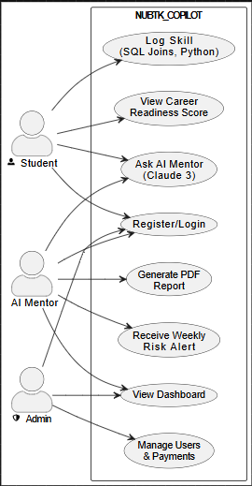

Figure 1: System Use Case Diagram Layout

